NAME : KONGARA SAI
REG NO : 192365025
SUB : INTERNET PROGRAMMING
SUB CODE :CSA4308

EXP-6
6.The online cake ordering system allows users to browse a variety of cakes by
category, flavor, and occasion, complete with detailed descriptions and images. Users can
register, log in, and manage their orders through a personal dashboard. The ordering
process includes selecting a cake, customizing options like size and message, entering
delivery details, and making secure payments via an integrated payment gateway. Admins
can manage cake inventory, track orders, and handle user accounts through an admin
panel. Users receive order confirmation emails and can track delivery status. The website
is fully responsive, providing a seamless shopping experience on all devices. Buy a Cake
is a portal which allows admin in developing counters to advertise and sell their cake. This
would permit rural communities to make their wares available to the rest of the world.
The proposed system is to develop the website for cake store. User can buy the nearby
cake available in app. An E Com App is a portal which allows admin in developing
products to promote and sell their goods. This would permit rural communities to make
their wares available to the rest of the world.
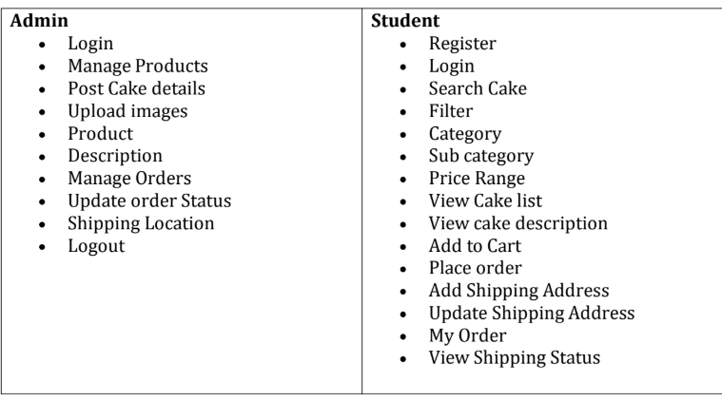
CODE:

<!DOCTYPE html>
<html>
<head>
<title>Buy a Cake</title>
<style>
body{font-family:Arial;background:#fff0f5;margin:0}
header{background:#d6336c;color:white;text-align:center;padding:20px}
nav{text-align:center;background:#8e2450;padding:15px}
nav a{color:white;margin:15px;text-decoration:none}
.container{padding:20px}
input,select,button{padding:10px;margin:5px}
.cakes{display:flex;flex-wrap:wrap;gap:20px}
.card{background:white;padding:15px;width:200px;text-align:center;
box-shadow:0 0 5px gray}
.card img{width:180px;height:150px;object-fit:cover}
button{background:#d6336c;color:white;border:0;cursor:pointer}
</style>
</head>
<body>
<header>
<h1>🍰 Buy a Cake</h1>
<p>Online Cake Ordering System</p>
</header>
<nav>
<a href="#home">Home</a>
<a href="#cakes">Cakes</a>
<a href="#cart">Cart</a>
<a href="#orders">My Orders</a>
<a href="#admin">Admin</a>
</nav>
<div class="container" id="home">
<h2>Welcome to Buy a Cake</h2>
<p>Order delicious cakes online for every occasion.</p>
</div>
<div class="container" id="cakes">
<h2>Search Cakes</h2>
<input type="text" id="search" placeholder="Search Cake" onkeyup="searchCake()">
<select id="category" onchange="searchCake()">
<option value="">All Categories</option><option>Birthday</option>
<option>Wedding</option><option>Chocolate</option>
</select>
<div class="cakes" id="cakeList"></div>
</div>
<div class="container" id="cart">
<h2>Shopping Cart</h2><p id="cartItems">Cart is empty</p>
<input id="address" placeholder="Shipping Address">
<button onclick="placeOrder()">Place Order</button>
</div>
<div class="container" id="orders">
<h2>My Orders</h2><p id="orderStatus">No orders yet</p>
</div>
<div class="container" id="admin">
<h2>Admin Panel</h2>
<input id="newCake" placeholder="Cake Name">
<button onclick="addCake()">Add Cake</button>
</div>
<script>
let cakes=[{name:"Chocolate Cake",category:"Chocolate",price:500},
{name:"Birthday Cake",category:"Birthday",price:700},
{name:"Wedding Cake",category:"Wedding",price:1500}];
let cart=[];
function display(data){cakeList.innerHTML=data.map((c,i)=>
`<div class="card"><h3>${c.name}</h3><p>${c.category}</p>
<p>₹${c.price}</p><button onclick="add(${i})">Add Cart</button></div>`).join("")}
function add(i){cart.push(cakes[i]);cartItems.innerText=cart.map(c=>c.name).join(", ")}
function searchCake(){let s=search.value.toLowerCase(),c=category.value;
display(cakes.filter(x=>x.name.toLowerCase().includes(s)&&(c==""||x.category==c)))}
function placeOrder(){if(cart.length&&address.value){orderStatus.innerText="Order Placed - Delivery Pending";alert("Order Successful")}else alert("Enter address and add cake")}
function addCake(){if(newCake.value){cakes.push({name:newCake.value,category:"New",price:500});display(cakes);newCake.value=""}}
display(cakes);
</script>
</body>
</html>
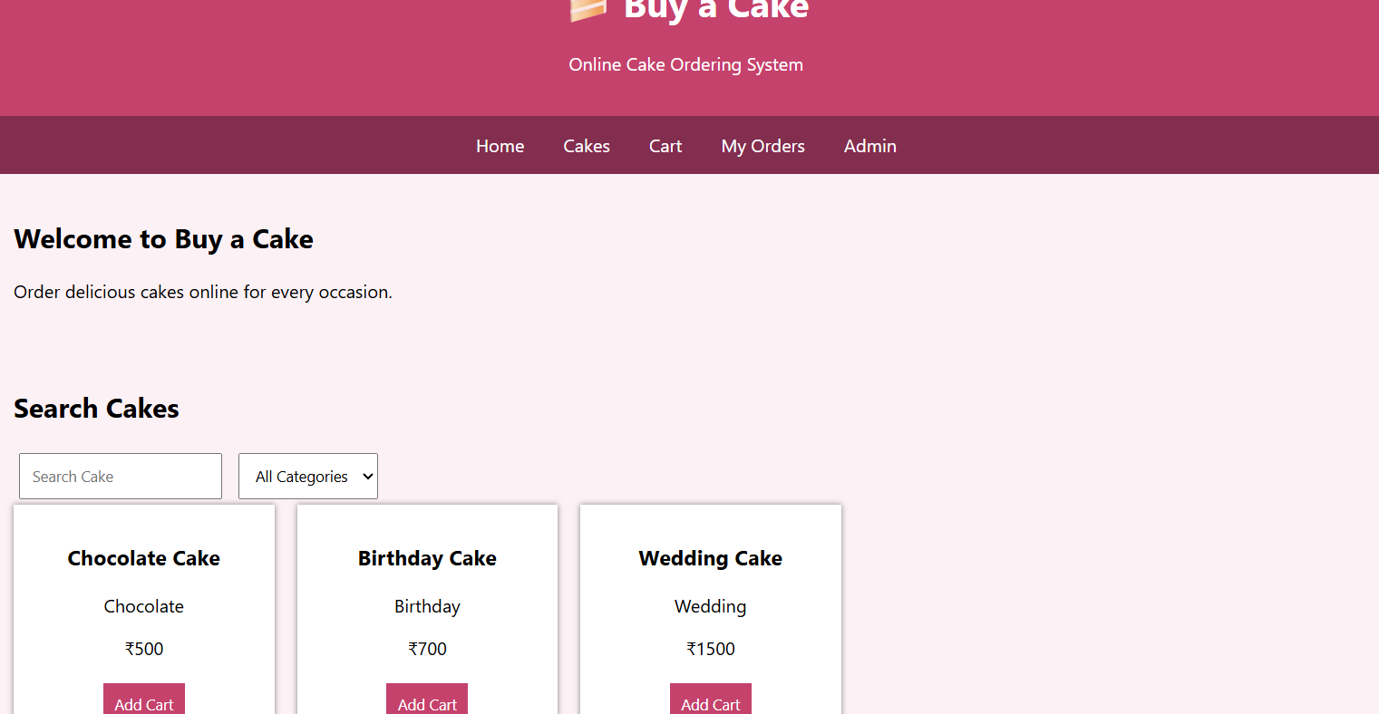

EXP-7
The online beauty parlour appointment booking system allows users to browse
available services, view stylist profiles, and check appointment slots in real-time. Users
can register, log in, and manage their appointments through a personal dashboard.
The booking process includes selecting services, choosing a stylist, selecting a date and
time, and making secure payments via an integrated payment gateway. Admins can
manage service offerings, stylist schedules, and user accounts through a comprehensive
admin panel. Users receive appointment confirmation emails and reminders, with the
option to reschedule or cancel appointments through their dashboard. The website is
fully responsive, ensuring an optimal experience on all devices. This website helps
customers to search for any beauty parlour and book appointments as they preferable
date and time.
Have reservations calendar
➢ Create, edit, and cancel reservations
➢ Lockout unavailable hours
➢ Get the crucial information for each date on the calendar
Customers’ personal account page
➢ Upcoming reservations
➢ Reservations history
➢ Personal data
Salon manager and staff member in order to control and manage reservations.
➢ Upcoming reservations
➢ Reservations calendar
➢ Add reservation
➢ Edit reservations
➢ Send an SMS or call to the customer
➢ customers leave feedback about their experiences and learn from their suggestions.
Accept online payments as a whole payment or as a partial deposit with Stripe or PayPal or
with one of the available payments
➢ Require full payment or a deposit
➢ Accept PayPal or Stripe
➢ Automatic cancellation of unpaid reservations
➢ We have more than twenty different payments platforms integration add-ons
CODE:

<!DOCTYPE html>
<html>
<head>
<title>Beauty Parlour Booking</title>
<style>
body{font-family:Arial;background:#fff5f8;margin:0}
header{background:#d63384;color:white;text-align:center;padding:20px}
nav{text-align:center;background:#8e2257;padding:15px}
nav a{color:white;margin:15px;text-decoration:none}
.container{padding:20px}
input,select,button{padding:10px;margin:5px}
button{background:#d63384;color:white;border:0;cursor:pointer}
.card{background:white;padding:15px;margin:10px;display:inline-block;
width:220px;box-shadow:0 0 5px gray;text-align:center}
#calendar{background:white;padding:20px}
</style>
</head>
<body>
<header>
<h1>💇 Beauty Parlour</h1>
<p>Online Appointment Booking System</p>
</header>
<nav>
<a href="#home">Home</a>
<a href="#services">Services</a>
<a href="#booking">Book</a>
<a href="#account">My Account</a>
<a href="#admin">Admin</a>
</nav>
<div class="container" id="home">
<h2>Welcome</h2>
<p>Search services, select a stylist and book your preferred appointment.</p>
</div>
<div class="container" id="services">
<h2>Beauty Services</h2>
<div class="card"><h3>Haircut</h3><p>₹300</p></div>
<div class="card"><h3>Hair Styling</h3><p>₹500</p></div>
<div class="card"><h3>Facial</h3><p>₹700</p></div>
<div class="card"><h3>Makeup</h3><p>₹1000</p></div>
</div>
<div class="container" id="booking">
<h2>Book Appointment</h2>
<input id="name" placeholder="Customer Name">
<select id="service"><option>Haircut</option><option>Facial</option>
<option>Makeup</option><option>Hair Styling</option></select>
<select id="stylist"><option>Choose Stylist</option>
<option>Priya</option><option>Anitha</option><option>Meena</option></select>
<input type="date" id="date">
<input type="time" id="time">
<select id="payment"><option>Full Payment</option>
<option>Partial Deposit</option><option>PayPal</option><option>Stripe</option></select>
<button onclick="book()">Book Appointment</button>
</div>
<div class="container" id="account">
<h2>My Account</h2>
<p id="status">No upcoming reservations.</p>
<button onclick="cancel()">Cancel Appointment</button>
<button onclick="feedback()">Give Feedback</button>
</div>
<div class="container" id="admin">
<h2>Salon Manager / Staff Panel</h2>
<p>Manage reservations, staff schedules and unavailable hours.</p>
<button onclick="lock()">Lock Unavailable Hours</button>
<button onclick="add()">Add Reservation</button>
<button onclick="edit()">Edit Reservation</button>
</div>
<script>
let booked=false;
function book(){
if(name.value&&date.value&&time.value&&stylist.value!="Choose Stylist"){
status.innerText="Appointment Confirmed: "+service.value+" with "+stylist.value+
" on "+date.value+" at "+time.value;
booked=true;alert("Appointment booked successfully!");
}else alert("Please fill all details");
}
function cancel(){if(booked){status.innerText="Appointment Cancelled";booked=false}
else alert("No appointment found")}
function feedback(){let f=prompt("Enter your feedback");
if(f)alert("Thank you for your feedback!")}
function lock(){alert("Selected time has been locked as unavailable")}
function add(){alert("New reservation added")}
function edit(){alert("Reservation updated successfully")}
</script>
</body>
</html>
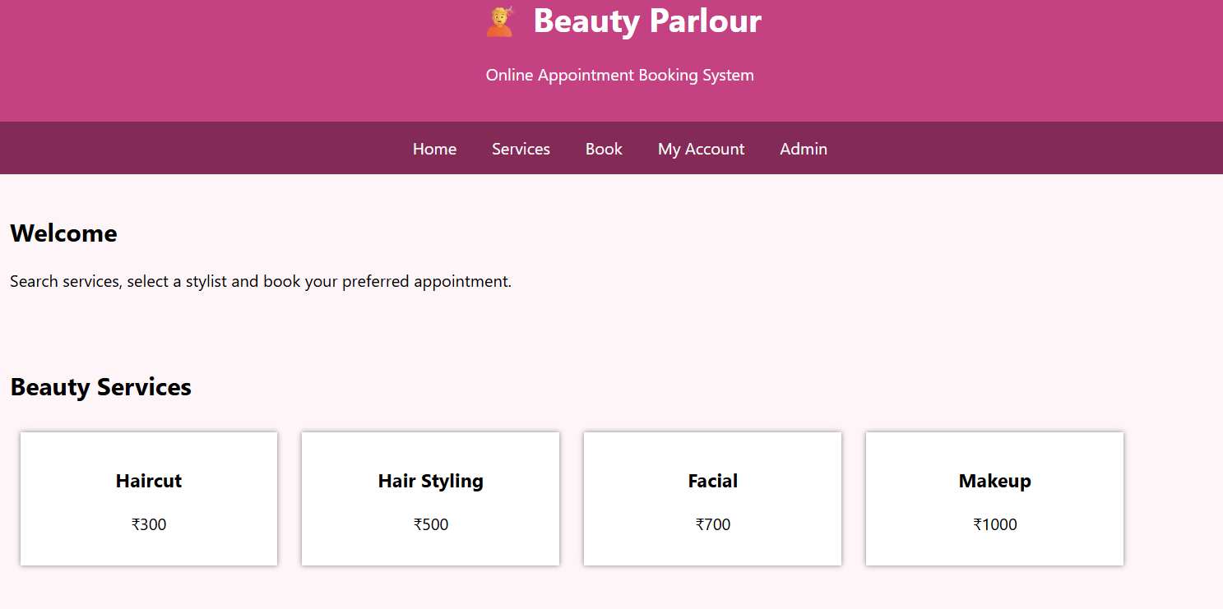
EXP-8
In an effort to streamline the appointment process and enhance patient experience,
MedCare Hospital has developed an online appointment booking system. This platform
allows patients to book appointments with doctors from various specialties at their
convenience. Key functionalities include user registration and login, browsing available
doctors and appointment slots, booking and canceling appointments, and receiving
appointment reminders via email or SMS. Patients can also view their appointment
history and update their personal details. The system ensures data security and

INTERNET PROGRAMMING
LAB EXPRIMENTS

compliance with healthcare regulations to protect patient information. This online service
aims to reduce wait times, minimize paperwork, and provide a seamless experience for
patients and healthcare providers alike. This website helps the patient to search any
hospital and book appointments as they prefer.
• Search Module
• Appointment Booking
• Check-in form Submitting
• Appointment management
• Schedule a timing
• Past appointment Management
Admin Features
• Manage appointments
• Manage doctors
• View Appointments statistics
• Rating Details
Patient Features
• Signup/Login.
• Can choose and book an appointment at the flexible time and date.
• Can search for doctor according to specialty and location.
• Can write reviews about the doctor and can select doctors according to otheruser
feedback.
• Can access all previous check-in details and medical past appointment
User
• User Registration
• User Login
• Search Location wise
• View Hosptial list
• Book Appointment
• View status
• View google map for single hospital
Hospital
• Hospital Registration
• Hosptial login
• Create hostpital details
• Update details
• Update location
CODE:
<!DOCTYPE html>
<html>
<head>
<title>MedCare Hospital</title>
<style>
body{font-family:Arial;margin:0;background:#eef8ff}
header{background:#087f9c;color:white;text-align:center;padding:20px}
nav{text-align:center;background:#05566b;padding:15px}
nav a{color:white;margin:12px;text-decoration:none}
.container{padding:20px}
input,select,button{padding:10px;margin:5px}
button{background:#087f9c;color:white;border:0;cursor:pointer}
.card{background:white;padding:15px;margin:10px;display:inline-block;
width:220px;box-shadow:0 0 5px gray}
</style>
</head>
<body>
<header><h1>🏥 MedCare Hospital</h1>
<p>Online Doctor Appointment System</p></header>
<nav>
<a href="#home">Home</a><a href="#search">Search</a>
<a href="#booking">Book Appointment</a><a href="#patient">Patient</a>
<a href="#admin">Admin</a><a href="#hospital">Hospital</a>
</nav>
<div class="container" id="home">
<h2>Welcome to MedCare Hospital</h2>
<p>Search hospitals and doctors and book appointments easily.</p>
</div>
<div class="container" id="search">
<h2>Search Doctor</h2>
<input id="location" placeholder="Enter Location">
<select id="specialty"><option>Cardiologist</option>
<option>Dermatologist</option><option>Neurologist</option></select>
<button onclick="searchDoctor()">Search</button>
<div class="card"><h3>Dr. Priya</h3><p>Cardiologist</p>
<p>Chennai</p><p>⭐ 4.5</p></div>
</div>
<div class="container" id="booking">
<h2>Book Appointment</h2>
<input id="patient" placeholder="Patient Name">
<input type="date" id="date"><input type="time" id="time">
<button onclick="book()">Book Appointment</button>
<p id="status">No appointment booked.</p>
</div>
<div class="container" id="patient">
<h2>Patient Account</h2>
<button onclick="login()">Signup / Login</button>
<button onclick="history()">View Appointment History</button>
<button onclick="checkin()">Submit Check-in Form</button>
<button onclick="cancel()">Cancel Appointment</button>
</div>
<div class="container" id="admin">
<h2>Admin Panel</h2>
<button>Manage Appointments</button>
<button>Manage Doctors</button>
<button>View Statistics</button>
<button>View Ratings</button>
</div>
<div class="container" id="hospital">
<h2>Hospital Panel</h2>
<input placeholder="Hospital Name"><input placeholder="Location">
<button>Create Hospital</button><button>Update Details</button>
<button onclick="map()">View Google Map</button>
</div>
<script>
function book(){if(patient.value&&date.value&&time.value)
status.innerText="Appointment Confirmed on "+date.value+" at "+time.value;
else alert("Enter all details")}
function cancel(){status.innerText="Appointment Cancelled"}
function login(){alert("Login / Registration Successful")}
function history(){alert("Previous appointments displayed")}
function checkin(){alert("Check-in form submitted")}
function searchDoctor(){alert("Searching doctors by specialty and location")}
function map(){alert("Opening Google Map for hospital")}
</script>
</body>
</html>
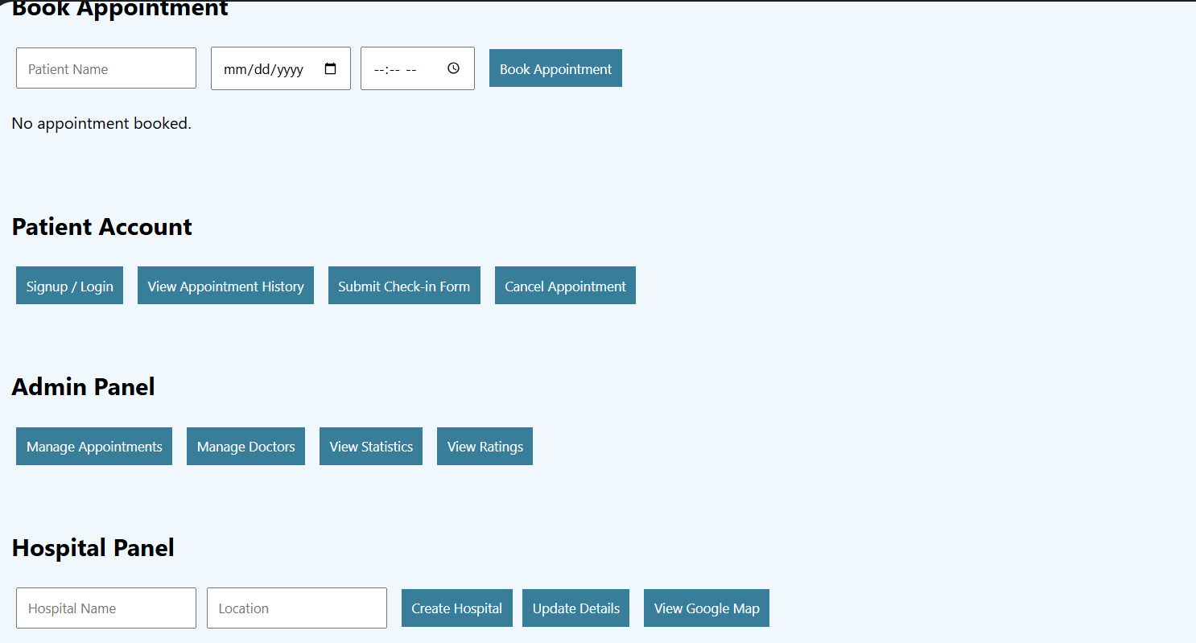

EXP-9
TechSavvy, a leading retailer of electronic gadgets, has launched an online shopping
platform to provide customers with a seamless and convenient shopping experience. The
website features a wide range of products, including smartphones, laptops, tablets, and
accessories, all categorized for easy browsing. Key functionalities include user
registration and login, product search and filtering, detailed product descriptions and
reviews, secure payment options, and order tracking. Customers can add items to their
cart, create wish lists, and receive personalized recommendations based on their browsing
and purchase history. The platform also offers exclusive online discounts and promotions,
ensuring customers get the best deals on the latest gadgets.The core of an online shop is
the product catalogue and the cart. The users browse products which are grouped in
categories and add the desired ones to the cart. Next, there is transactionhandling, which
in its simplest form consists in the order being sent via e-mail to the seller, butmost often

INTERNET PROGRAMMING
LAB EXPRIMENTS

it takes the whole buying process through separate order statuses.
➢ Products should be logically categorized, with the most popular categories listed
first.Display all the available categories for shopping on the home page.
➢ Display all the subcategories on the home page, that are associated with any particular
item.
➢ Admin has the authority to add new particulars to the items list whenever needed.
➢ Permission to the administrator to remove items, anytime.
➢ Allows the admin to modify the price of each item, whenever required or felt like.

items list.
Use Cases
1. Visit a site
2. Login
3. Search for Items
4. Check Availability of Items
5. Add Items to Shopping Cart
6. Edit Items in the Shopping Cart
7. remove Items from the Shopping Cart
8. Check out the Shopping Cart
9. Check Order Status
10. Browse Order History
11. Display Item Details
12. Logout
13. Leave a site
CODE:
<!DOCTYPE html>
<html>
<head>
<title>TechSavvy Online Store</title>
<style>
body{font-family:Arial;margin:0;background:#f4f6f8}
header{background:#172b4d;color:white;text-align:center;padding:20px}
nav{text-align:center;background:#0d1b2a;padding:15px}
nav a{color:white;margin:12px;text-decoration:none}
.container{padding:20px}
input,select,button{padding:10px;margin:5px}
button{background:#172b4d;color:white;border:0;cursor:pointer}
.card{background:white;padding:15px;margin:10px;display:inline-block;
width:200px;box-shadow:0 0 5px gray;text-align:center}
</style>
</head>
<body>
<header><h1>🛒 TechSavvy</h1>
<p>Online Electronic Gadgets Store</p></header>
<nav>
<a href="#home">Home</a><a href="#products">Products</a>
<a href="#cart">Cart</a><a href="#orders">Orders</a>
<a href="#login">Login</a><a href="#admin">Admin</a>
</nav>
<div class="container" id="home">
<h2>Product Categories</h2>
<button onclick="show('Smartphones')">Smartphones</button>
<button onclick="show('Laptops')">Laptops</button>
<button onclick="show('Tablets')">Tablets</button>
<button onclick="show('Accessories')">Accessories</button>
</div>
<div class="container" id="products">
<h2>Search Products</h2>
<input id="search" placeholder="Search Items" onkeyup="search()">
<div id="list"></div>
</div>
<div class="container" id="cart">
<h2>Shopping Cart</h2><p id="cartItems">Cart is empty</p>
<button onclick="checkout()">Checkout</button>
</div>
<div class="container" id="orders">
<h2>Order Status</h2><p id="order">No orders available</p>
<button onclick="history()">Order History</button>
</div>
<div class="container" id="login">
<h2>Customer Login</h2>
<input placeholder="Email"><input type="password" placeholder="Password">
<button onclick="login()">Login</button>
</div>
<div class="container" id="admin">
<h2>Admin Panel</h2>
<input id="item" placeholder="Product Name">
<input id="price" placeholder="Price">
<input id="description" placeholder="Description">
<button onclick="add()">Add Product</button>
<button onclick="remove()">Remove Product</button>
<button onclick="update()">Update Product</button>
</div>
<script>
let products=["iPhone","Laptop","Tablet","Headphones"],cart=[];
function show(c){alert("Showing "+c+" products")}
function display(){list.innerHTML=products.map((p,i)=>
`<div class="card"><h3>${p}</h3><button onclick="addCart(${i})">Add Cart</button></div>`).join("")}
function search(){let s=search.value.toLowerCase();list.innerHTML=products.filter(p=>p.toLowerCase().includes(s)).map(p=>`<div class="card">${p}</div>`).join("")}
function addCart(i){cart.push(products[i]);cartItems.innerText=cart.join(", ")}
function checkout(){if(cart.length){order.innerText="Order Placed - Processing"}else alert("Cart is empty")}
function history(){alert("Previous orders displayed")}
function login(){alert("Login Successful")}
function add(){if(item.value){products.push(item.value);display()}}
function remove(){products.pop();display()}
function update(){alert("Product price and description updated")}
display();
</script>
</body>
</html>
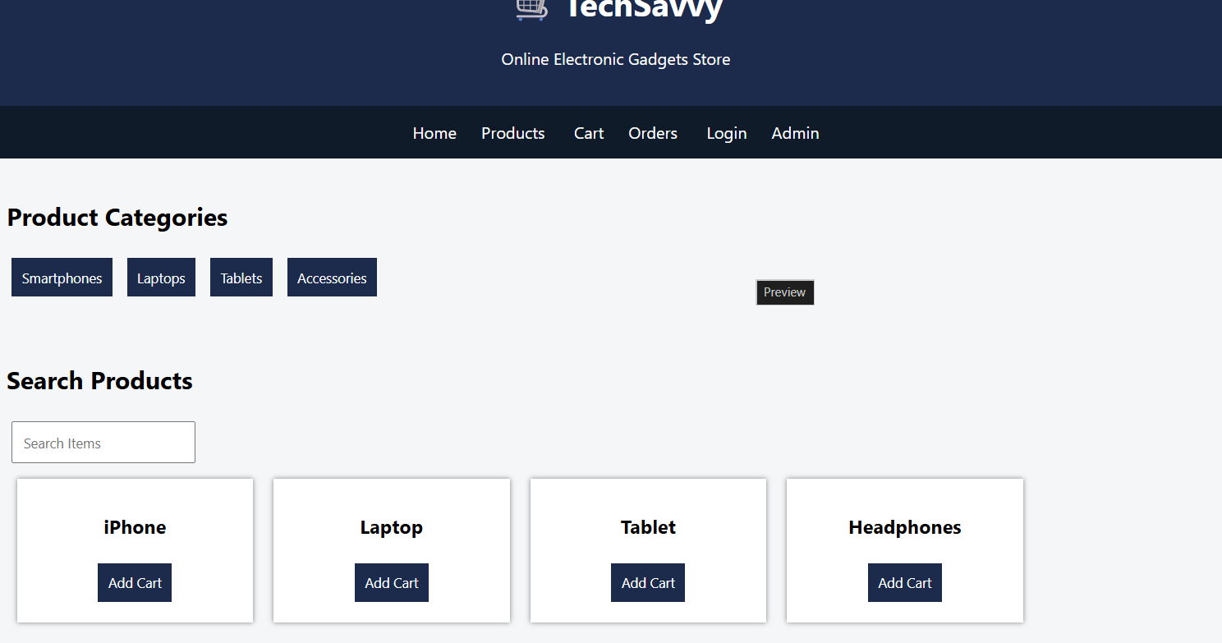
EXP-10
10. StyleHub, a premier online fashion retailer, introduces its comprehensive e-commerce
platform designed to cater to fashion enthusiasts. The website offers an extensive
collection of clothing, footwear, and accessories for men, women, and children, with
categories such as casual wear, formal attire, and seasonal collections. Key functionalities
include user registration and login, advanced search and filtering options, detailed
product descriptions with high-resolution images, customer reviews, and size guides. The
platform supports secure payment methods, order tracking, and an easy return and
exchange policy. Customers can create wish lists, receive personalized style
recommendations, and enjoy exclusive online discounts and flash sales. StyleHub aims to
provide a seamless and enjoyable shopping experience, keeping users up-to-date with the
latest fashion trends.The core of an online shop is the product catalogue and the cart. The
users browse products which are grouped in categories and add the desired ones to the
cart. Next, there is transaction handling, which in its simplest form consists in the order
being sent via e-mail to the seller, but most often it takes the whole buying process through
separate order statuses.

➢ The key to helping customers find the products they need quickly is to offer a user-
friendly navigation system.

➢ Products should be logically categorized, with the most popular categories listed first.

INTERNET PROGRAMMING
LAB EXPRIMENTS

➢ Display all the available categories for shopping on the home page.
➢ Display all the subcategories on the home page, that are associated with any particular
item.
➢ Admin has the authority to add new particulars to the items list whenever needed.
➢ Permission to the administrator to remove items, anytime.
➢ Allows the admin to modify the price of each item, whenever required or felt like.
➢ Admin has the authority to update the description of each item.
➢ Permission to the admin to view information about each customer who checkouts the
items list.
Use Cases
2. Visit a site
2. Login
3. Search for Items
4. Check Availability of Items
5. Add Items to Shopping Cart
6. Edit Items in the Shopping Cart
7. remove Items from the Shopping Cart
8. Check out the Shopping Cart
9. Check Order Status
10. Browse Order History
11. Display Item Details
12. Logout
13. Leave a site

CODE:

<!DOCTYPE html>
<html>
<head>
<title>StyleHub Fashion Store</title>
<style>
body{font-family:Arial;margin:0;background:#fff5f5}
header{background:#9c27b0;color:white;text-align:center;padding:20px}
nav{text-align:center;background:#4a148c;padding:15px}
nav a{color:white;margin:12px;text-decoration:none}
.container{padding:20px}
input,select,button{padding:10px;margin:5px}
button{background:#9c27b0;color:white;border:0;cursor:pointer}
.card{background:white;padding:15px;margin:10px;display:inline-block;
width:200px;box-shadow:0 0 5px gray;text-align:center}
</style>
</head>
<body>
<header><h1>👗 StyleHub</h1>
<p>Online Fashion Shopping</p></header>
<nav>
<a href="#home">Home</a><a href="#products">Products</a>
<a href="#cart">Cart</a><a href="#orders">Orders</a>
<a href="#login">Login</a><a href="#admin">Admin</a>
</nav>
<div class="container" id="home">
<h2>Fashion Categories</h2>
<button onclick="show('Men')">Men</button>
<button onclick="show('Women')">Women</button>
<button onclick="show('Kids')">Kids</button>
<button onclick="show('Footwear')">Footwear</button>
<button onclick="show('Accessories')">Accessories</button>
</div>
<div class="container" id="products">
<h2>Search Products</h2>
<input id="search" placeholder="Search Fashion" onkeyup="search()">
<div id="list"></div>
</div>
<div class="container" id="cart">
<h2>Shopping Cart</h2><p id="cartItems">Cart is empty</p>
<button onclick="checkout()">Checkout</button>
</div>
<div class="container" id="orders">
<h2>Order Status</h2><p id="order">No orders available</p>
<button onclick="history()">Order History</button>
</div>
<div class="container" id="login">
<h2>Customer Login</h2>
<input placeholder="Email"><input type="password" placeholder="Password">
<button onclick="login()">Login</button>
</div>
<div class="container" id="admin">
<h2>Admin Panel</h2>
<input id="item" placeholder="Product Name">
<input id="price" placeholder="Price">
<input id="description" placeholder="Description">
<button onclick="add()">Add Product</button>
<button onclick="remove()">Remove Product</button>
<button onclick="update()">Update Product</button>
</div>
<script>
let products=["T-Shirt","Jeans","Dress","Shoes","Handbag"],cart=[];
function show(c){alert("Showing "+c+" products")}
function display(){list.innerHTML=products.map((p,i)=>
`<div class="card"><h3>${p}</h3><p>Available</p>
<button onclick="addCart(${i})">Add Cart</button></div>`).join("")}
function search(){let s=document.getElementById("search").value.toLowerCase();
list.innerHTML=products.filter(p=>p.toLowerCase().includes(s)).map(p=>
`<div class="card">${p}<br><button>Add Cart</button></div>`).join("")}
function addCart(i){cart.push(products[i]);cartItems.innerText=cart.join(", ")}
function checkout(){if(cart.length)order.innerText="Order Placed - Processing";
else alert("Cart is empty")}
function history(){alert("Previous orders displayed")}
function login(){alert("Login Successful")}
function add(){if(item.value){products.push(item.value);display()}}
function remove(){products.pop();display()}
function update(){alert("Product price and description updated")}
display();
</script>
</body>
</html>
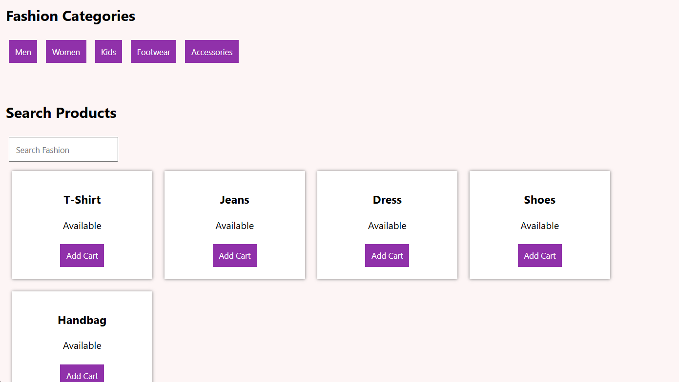

11. Home Finder, an innovative online real estate platform, is designed to simplify the
property search and transaction process for buyers, sellers, and renters. The website
features a comprehensive database of residential and commercial properties, with
advanced search filters for location, price, type, and amenities. Key functionalities include
user registration and login, detailed property listings with high-quality images and virtual
tours, and interactive maps to explore neighborhood features. Users can schedule
property viewings, save favorite listings, and receive notifications for new or updated
properties matching their criteria. The platform also offers tools for property valuation,
mortgage calculators, and direct communication with real estate agents. Home Finder
aims to make the property search process efficient and transparent, providing users with
valuable. This website helps the user to search and book lands/houses in their required
area in their budget.
➢ Provide a login page for buyers and store their username and password in the database
and can save the search criteria for the buyers.
➢ Helps the buyers to use the same search criteria rather than creating a new criterion
every time the buyer performs the search.
➢ Add more advertisements on the website or links to another website.
➢ Add agent and company search functionality.
➢ Displaying the search results on Google Maps and locating the area where the property
listing is located.
➢ It should be friendly and pretty
➢ Store and give details of properties
➢ Maintain record of customers visited the website

CODE:
<!DOCTYPE html>
<html>
<head>
<title>Home Finder</title>
<style>
body{font-family:Arial;margin:0;background:#eef5ff}
header{background:#1769aa;color:white;text-align:center;padding:20px}
nav{text-align:center;background:#0d47a1;padding:15px}
nav a{color:white;margin:12px;text-decoration:none}
.container{padding:20px}
input,select,button{padding:10px;margin:5px}
button{background:#1769aa;color:white;border:0;cursor:pointer}
.card{background:white;padding:15px;margin:10px;display:inline-block;
width:220px;box-shadow:0 0 5px gray}
</style>
</head>
<body>
<header><h1>🏠 Home Finder</h1>
<p>Find Your Dream Property</p></header>
<nav>
<a href="#home">Home</a><a href="#search">Search</a>
<a href="#properties">Properties</a><a href="#login">Login</a>
<a href="#agent">Agents</a>
</nav>
<div class="container" id="home">
<h2>Property Categories</h2>
<button>House</button><button>Apartment</button>
<button>Land</button><button>Commercial</button>
</div>
<div class="container" id="search">
<h2>Search Property</h2>
<input id="location" placeholder="Location">
<input id="budget" placeholder="Maximum Budget">
<select><option>House</option><option>Land</option>
<option>Apartment</option></select>
<button onclick="search()">Search</button>
</div>
<div class="container" id="properties">
<h2>Available Properties</h2>
<div class="card"><h3>3BHK House</h3><p>Chennai</p>
<p>₹50 Lakhs</p><button onclick="view()">View Details</button></div>
<div class="card"><h3>Residential Land</h3><p>Coimbatore</p>
<p>₹20 Lakhs</p><button onclick="view()">View Details</button></div>
</div>
<div class="container" id="login">
<h2>Buyer Login</h2>
<input placeholder="Username"><input type="password" placeholder="Password">
<button onclick="login()">Login</button>
</div>
<div class="container" id="agent">
<h2>Agent Search</h2>
<input placeholder="Agent or Company Name">
<button onclick="agent()">Search Agent</button>
<button onclick="map()">View Location on Google Maps</button>
</div>
<script>
function search(){alert("Searching properties based on location and budget")}
function view(){alert("Property details and images displayed")}
function login(){alert("Buyer Login Successful")}
function agent(){alert("Agent and company details displayed")}
function map(){alert("Property location displayed on Google Maps")}
</script>
</body>
</html>
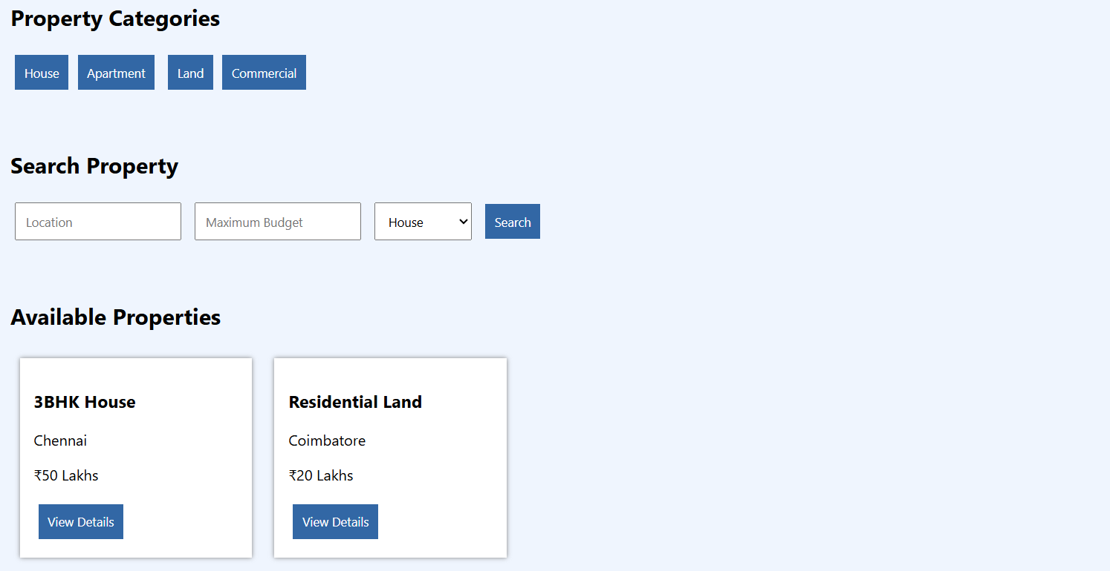

12. InsureEasy, a cutting-edge online insurance management platform, is designed to
streamline the insurance process for users. The website allows customers to easily
compare and purchase various insurance policies, including health, auto, and home
insurance. Key functionalities include user registration and login, a policy comparison
tool, detailed policy descriptions, and secure online applications. Users can view and
manage their existing policies, make premium payments, and file claims through an
intuitive dashboard. The platform also provides personalized recommendations based on
user profiles and needs, and sends automated reminders for policy renewals and
upcoming payments. InsureEasy aims to enhance user convenience and provide
comprehensive support for all insurance-related needs.This system maintains
information of managers who can deal with agents and customers. In existing system, the
manual procedure is followed where records are used to maintain data which is a time
taking process and requires manpower and calculating commissions dues. Etc are done
manually. This system is where agents send SMS alerts to the policyholder to remind them
before and exceed the data of due.
Admin
• Login
• Approve Agent login
• View all agent details
Agents
• Register
• Login
• Create Customer
• Manager Customer Details
• Manage Policy Details
• Send SMS Alert
User
• Login
• Manage policy details
• Get sms alert

CODE:
<!DOCTYPE html>
<html>
<head>
<title>InsureEasy</title>
<style>
body{font-family:Arial;margin:0;background:#f1f8e9}
header{background:#388e3c;color:white;text-align:center;padding:20px}
nav{text-align:center;background:#1b5e20;padding:15px}
nav a{color:white;margin:12px;text-decoration:none}
.container{padding:20px}
input,select,button{padding:10px;margin:5px}
button{background:#388e3c;color:white;border:0;cursor:pointer}
.card{background:white;padding:15px;margin:10px;display:inline-block;
width:220px;box-shadow:0 0 5px gray}
</style>
</head>
<body>
<header><h1>🛡️ InsureEasy</h1>
<p>Online Insurance Management System</p></header>
<nav>
<a href="#home">Home</a><a href="#policies">Policies</a>
<a href="#login">Login</a><a href="#admin">Admin</a>
<a href="#agent">Agent</a><a href="#user">User</a>
</nav>
<div class="container" id="home">
<h2>Insurance Policies</h2>
<div class="card"><h3>Health Insurance</h3><p>₹5000/year</p></div>
<div class="card"><h3>Vehicle Insurance</h3><p>₹3000/year</p></div>
<div class="card"><h3>Home Insurance</h3><p>₹7000/year</p></div>
</div>
<div class="container" id="policies">
<h2>Manage Policy</h2>
<input placeholder="Customer Name">
<select><option>Health</option><option>Vehicle</option><option>Home</option></select>
<button onclick="policy()">Create Policy</button>
<button onclick="pay()">Pay Premium</button>
</div>
<div class="container" id="login">
<h2>Login</h2><input placeholder="Username">
<input type="password" placeholder="Password">
<button onclick="login()">Login</button>
</div>
<div class="container" id="admin">
<h2>Admin Panel</h2>
<button>Approve Agent Login</button><button>View Agent Details</button>
</div>
<div class="container" id="agent">
<h2>Agent Panel</h2>
<button>Create Customer</button><button>Manage Customer</button>
<button>Manage Policy</button><button onclick="sms()">Send SMS Alert</button>
</div>
<div class="container" id="user">
<h2>User Panel</h2><button>View Policy</button>
<button onclick="sms()">Get SMS Alert</button>
</div>
<script>
function login(){alert("Login Successful")}
function policy(){alert("Policy Created Successfully")}
function pay(){alert("Premium Payment Successful")}
function sms(){alert("SMS Alert Sent to Customer")}
</script>
</body>
</html>
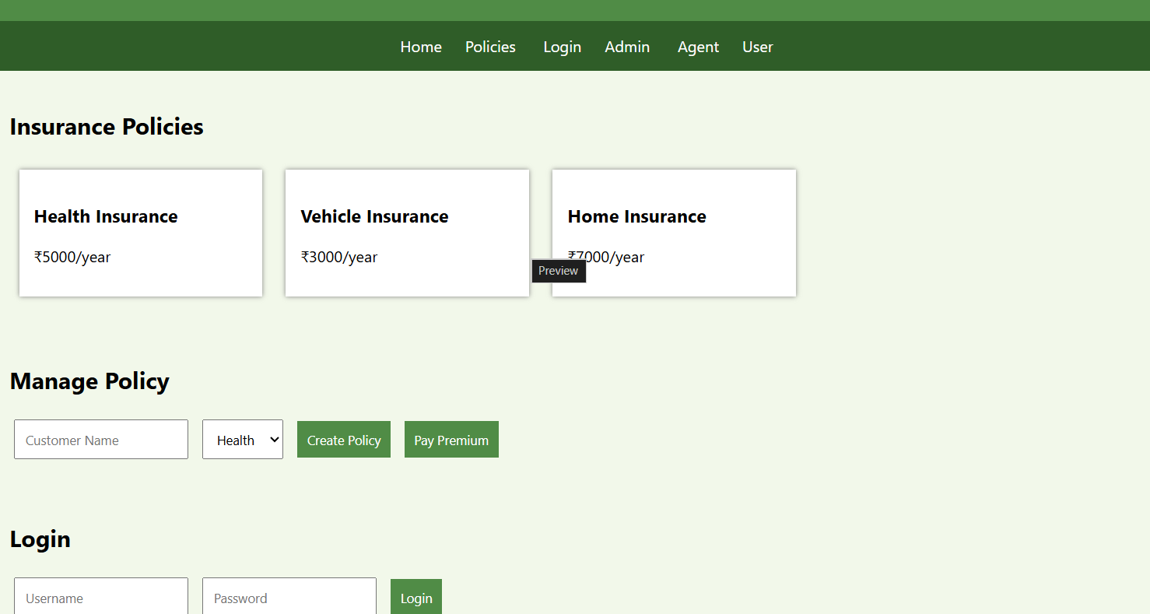

13. BlossomGifts, a user-friendly online platform, offers a seamless experience for ordering
flowers and gifts for any occasion. The website features a diverse selection of floral
arrangements, gift baskets, and personalized gifts, all organized by occasion, recipient,
and price range. Key functionalities include user registration and login, a customizable
order system with options for delivery dates and times, and detailed product descriptions
with high-quality images. Customers can track their orders in real-time, schedule future
deliveries, and receive order confirmations via email or SMS. The platform also supports
secure payment methods and provides special promotions and discounts for loyal
customers. BlossomGifts aims to make sending thoughtful gifts and flowers easy and
convenient, ensuring timely delivery and customer satisfaction.

➢ The key to helping customers find the products they need quickly is to offer a user-
friendly navigation system.

➢ Products should be logically categorized, with the most popular categories listed first.
➢ Display all the available categories for shopping on the home page.
➢ Display all the subcategories on the home page, that are associated with any particular
item.
➢ Admin has the authority to add new particulars to the items list whenever needed.
➢ Permission to the administrator to remove items, anytime.
➢ Allows the admin to modify the price of each item, whenever required or felt like.
➢ Permission to the admin to view information about each customer who checkouts the
items list.
Use Cases

Edit (Change, Delete) Customer Info
Inquire about ... via email
Maintain (add, change, delete) Inventory
View Order Summary

Visit a site
Login Search for Items
Check Availability of Items
Add Items to Shopping Cart
Edit Items in the Shopping Cart
remove Items from the Shopping Cart
Check out the Shopping Cart
Check Order Status
Browse Order History
Display Item Details
Logout
Leave a site

CODE
<!DOCTYPE html>
<html>
<head>
<title>BlossomGifts</title>
<style>
body{font-family:Arial;margin:0;background:#fff0f5}
header{background:#e91e63;color:white;text-align:center;padding:20px}
nav{text-align:center;background:#880e4f;padding:15px}
nav a{color:white;margin:12px;text-decoration:none}
.container{padding:20px}
input,select,button{padding:10px;margin:5px}
button{background:#e91e63;color:white;border:0;cursor:pointer}
.card{background:white;padding:15px;margin:10px;display:inline-block;
width:200px;box-shadow:0 0 5px gray;text-align:center}
</style>
</head>
<body>
<header><h1>🌸 BlossomGifts</h1>
<p>Flowers and Gifts for Every Occasion</p></header>
<nav>
<a href="#home">Home</a><a href="#products">Products</a>
<a href="#cart">Cart</a><a href="#orders">Orders</a>
<a href="#admin">Admin</a>
</nav>
<div class="container" id="home">
<h2>Categories</h2><button>Birthday</button>
<button>Wedding</button><button>Anniversary</button>
<button>Flowers</button><button>Gift Baskets</button>
</div>
<div class="container" id="products">
<h2>Products</h2>
<input placeholder="Search Products">
<div class="card"><h3>Rose Bouquet</h3><p>₹500</p>
<button onclick="cart()">Add Cart</button></div>
<div class="card"><h3>Gift Basket</h3><p>₹1000</p>
<button onclick="cart()">Add Cart</button></div>
</div>
<div class="container" id="cart">
<h2>Shopping Cart</h2><p>Rose Bouquet added to cart</p>
<input type="date"><input type="time">
<button onclick="order()">Checkout</button>
</div>
<div class="container" id="orders">
<h2>Order Status</h2><p id="status">No Order</p>
</div>
<div class="container" id="admin">
<h2>Admin Panel</h2>
<input placeholder="Product Name"><input placeholder="Price">
<button>Add Product</button><button>Remove Product</button>
<button>Update Product</button>
</div>
<script>
function cart(){alert("Product added to cart")}
function order(){status.innerText="Order Confirmed - Delivery Scheduled"}
</script>
</body>
</html>
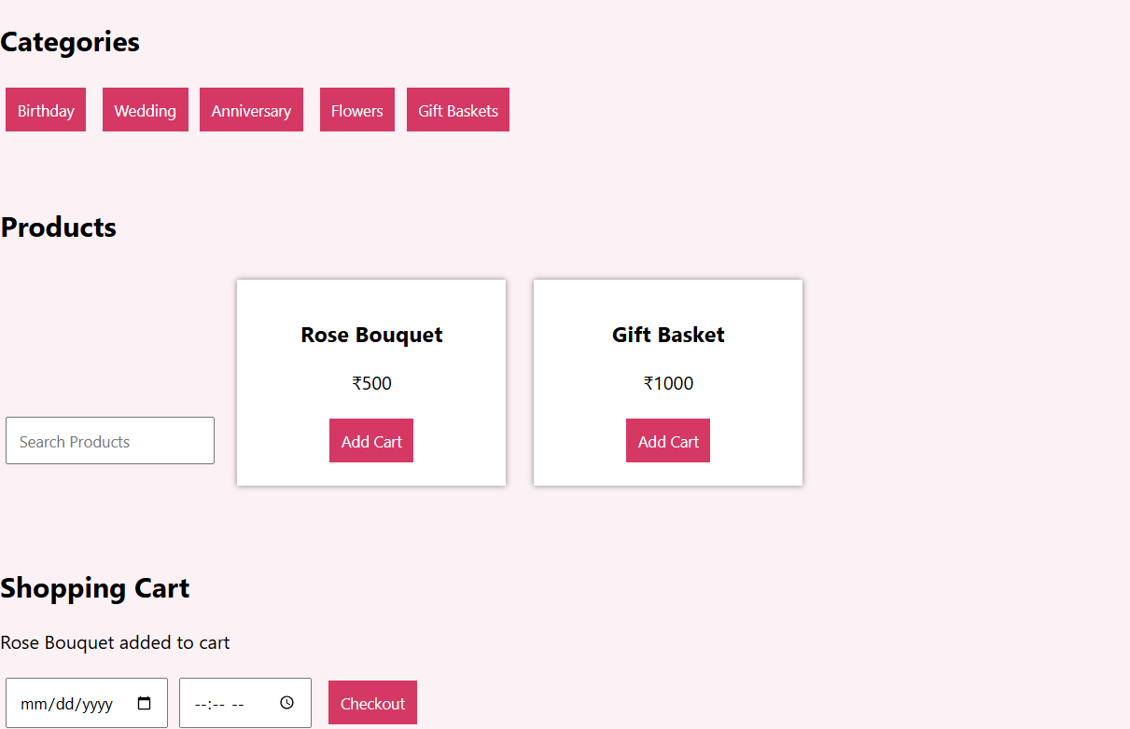

14. ReNewMarket, a dynamic online marketplace, connects buyers and sellers of second-
hand goods with ease. The website features a broad range of categories, including

electronics, furniture, clothing, and collectibles. Key functionalities include user
registration and login, a user-friendly listing creation tool for sellers, and advanced search
and filtering options for buyers. Listings include detailed descriptions, photos, and pricing
information, with the option to negotiate prices directly with sellers. Users can track their
transactions, leave feedback, and manage their favorite items and notifications. The
platform also provides secure payment options and a simple process for arranging item
pick-ups or deliveries. ReNewMarket aims to provide a reliable and convenient space for
exchanging pre-loved items while promoting sustainability
➢User Management
The system login successfully and the network connection is working.
✓ The administrator set login account and password.
✓ Editing User
✓ Deleting User
➢ Category Management
✓ Add category information.
✓ Delete category information
➢ Commodity Management
✓ Editing Commodity
✓ deleting Commodity
➢ Order Management
✓ Change logistics status: (Shipped/ Received)
✓ Delete Order

CODE
<!DOCTYPE html>
<html>
<head>
<title>ReNewMarket</title>
<style>
body{font-family:Arial;margin:0;background:#f5f5f5}
header{background:#455a64;color:white;text-align:center;padding:20px}
nav{text-align:center;background:#263238;padding:15px}
nav a{color:white;margin:12px;text-decoration:none}
.container{padding:20px}
input,select,button{padding:10px;margin:5px}
button{background:#455a64;color:white;border:0;cursor:pointer}
.card{background:white;padding:15px;margin:10px;display:inline-block;
width:200px;box-shadow:0 0 5px gray}
</style>
</head>
<body>
<header><h1>♻️ ReNewMarket</h1>
<p>Buy and Sell Pre-Loved Products</p></header>
<nav><a href="#home">Home</a><a href="#products">Products</a>
<a href="#login">Login</a><a href="#admin">Admin</a>
<a href="#orders">Orders</a></nav>
<div class="container" id="home">
<h2>Categories</h2><button>Electronics</button>
<button>Furniture</button><button>Clothing</button>
<button>Collectibles</button>
</div>
<div class="container" id="products">
<h2>Search Items</h2><input placeholder="Search Used Items">
<div class="card"><h3>Used Laptop</h3><p>₹25000</p>
<button onclick="buy()">Buy</button></div>
<div class="card"><h3>Used Sofa</h3><p>₹8000</p>
<button onclick="buy()">Buy</button></div>
</div>
<div class="container" id="login">
<h2>User Management</h2><input placeholder="Username">
<input type="password" placeholder="Password">
<button onclick="login()">Login</button>
</div>
<div class="container" id="orders">
<h2>Order Management</h2><p id="status">No orders</p>
<button onclick="ship()">Mark as Shipped</button>
<button onclick="receive()">Mark as Received</button>
</div>
<div class="container" id="admin">
<h2>Admin Panel</h2><button>Add Category</button>
<button>Delete Category</button><button>Edit Commodity</button>
<button>Delete Commodity</button><button>Delete Order</button>
</div>
<script>
function login(){alert("Login Successful")}
function buy(){status.innerText="Order Placed"}
function ship(){status.innerText="Shipped"}
function receive(){status.innerText="Received"}
</script>
</body>
</html>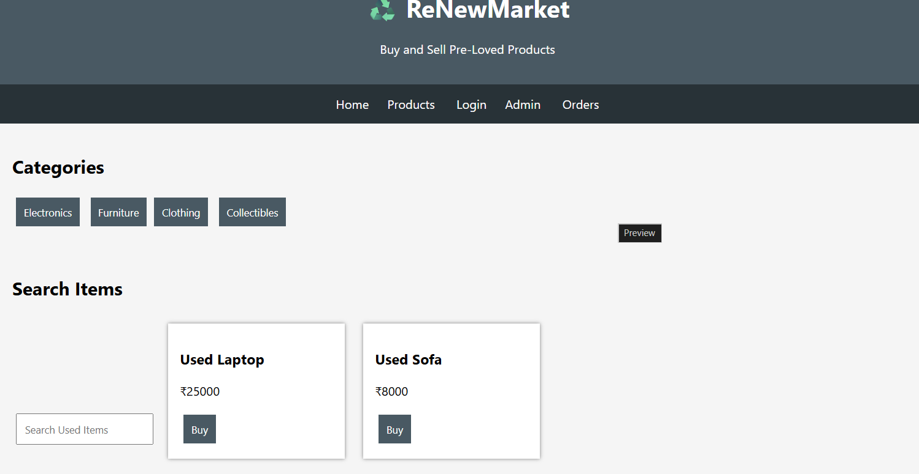

15. EasyToll, an advanced online toll payment system, simplifies the process of managing
toll fees for drivers. The website allows users to register and log in to access their toll
account, where they can view and pay outstanding toll charges from various toll gates.

Key functionalities include real-time toll balance updates, automatic payment options,
and the ability to add or update vehicle details. Users can view detailed transaction
history, set up recurring payments for frequent routes, and receive notifications for
upcoming toll charges. The platform also supports secure payment methods and
provides a user-friendly interface for managing toll accounts and reviewing payment
summaries. EasyToll aims to enhance the convenience of toll payments and reduce wait
times at toll booths, This website should help the user to pay toll in advance therefore
not to wait in queue while travelling.
Admin:
• Login
• Manage User & Toll pass
• Manage Toll login
• Approve toll pass
• Generate QR Code
• Create Toll details
User:
• Register
• Login
• Add Money – eWallet
• Buy Toll eTicket
• Apply New toll pass
• Renewal toll pass
• Apply Toll pass
• Get QR Code for Toll pass

Toll Gate User :
• Login

• Scan QR
• Verify toll pass ID
• Verify Toll ticket
• Update toll location
CODE:
<!DOCTYPE html>
<html>
<head>
<title>EasyToll</title>
<style>
body{font-family:Arial;margin:0;background:#e8f5e9}
header{background:#2e7d32;color:white;text-align:center;padding:20px}
nav{text-align:center;background:#1b5e20;padding:15px}
nav a{color:white;margin:12px;text-decoration:none}
.container{padding:20px}
input,button{padding:10px;margin:5px}
button{background:#2e7d32;color:white;border:0;cursor:pointer}
.card{background:white;padding:15px;margin:10px;display:inline-block;
width:220px;box-shadow:0 0 5px gray}
</style>
</head>
<body>
<header><h1>🚗 EasyToll</h1>
<p>Online Toll Payment and Toll Pass System</p></header>
<nav><a href="#home">Home</a><a href="#user">User</a>
<a href="#pass">Toll Pass</a><a href="#admin">Admin</a>
<a href="#gate">Toll Gate</a></nav>
<div class="container" id="home">
<h2>EasyToll Services</h2>
<button>Buy e-Ticket</button><button>Apply Toll Pass</button>
<button>Renew Pass</button>
</div>
<div class="container" id="user">
<h2>User Account</h2>
<input placeholder="Username"><input type="password" placeholder="Password">
<button onclick="login()">Login</button>
<button onclick="money()">Add Money to eWallet</button>
</div>
<div class="container" id="pass">
<h2>Toll Pass</h2><input placeholder="Vehicle Number">
<button onclick="apply()">Apply New Pass</button>
<button onclick="qr()">Get QR Code</button>
</div>
<div class="container" id="admin">
<h2>Admin Panel</h2><button>Manage Users</button>
<button>Manage Toll Pass</button><button>Approve Pass</button>
<button>Generate QR Code</button><button>Create Toll Details</button>
</div>
<div class="container" id="gate">
<h2>Toll Gate User</h2><input placeholder="Scan QR Code">
<button onclick="scan()">Scan QR</button>
<button>Verify Toll Pass</button><button>Verify Toll Ticket</button>
<button>Update Toll Location</button>
</div>
<script>
function login(){alert("User Login Successful")}
function money(){alert("Money Added to eWallet")}
function apply(){alert("Toll Pass Application Submitted")}
function qr(){alert("QR Code Generated")}
function scan(){alert("QR Code Verified Successfully")}
</script>
</body>
</html>
